**ermodelling**

A Simple Case on ER Modelling

• Goal – to demonstrate how to build an E-R model from a simple Statement of Objectives of a movie store. ( given very clearly in statement forms)

Scenario:

• A video store rents movies to members.

• Each movie in the store has a title and is identified by a unique movie number.

• A movie can be in VHS, VCD, or DVD format.

• Each movie belongs to one of a given set of categories (action, adventure, comedy, ... )

• The store has a name and a (unique) phone number for each member.

• Each member may provide a favorite movie category (used for marketing purposes).

• There are two types of members:

o Golden Members:

o Bronze Members:

• Using their credit cards gold members can rent one or more movies and bronze members max. of one movie.

• A member may have a number of dependents (with known names).

• Each dependent is allowed to rent one (1) movie at a time.

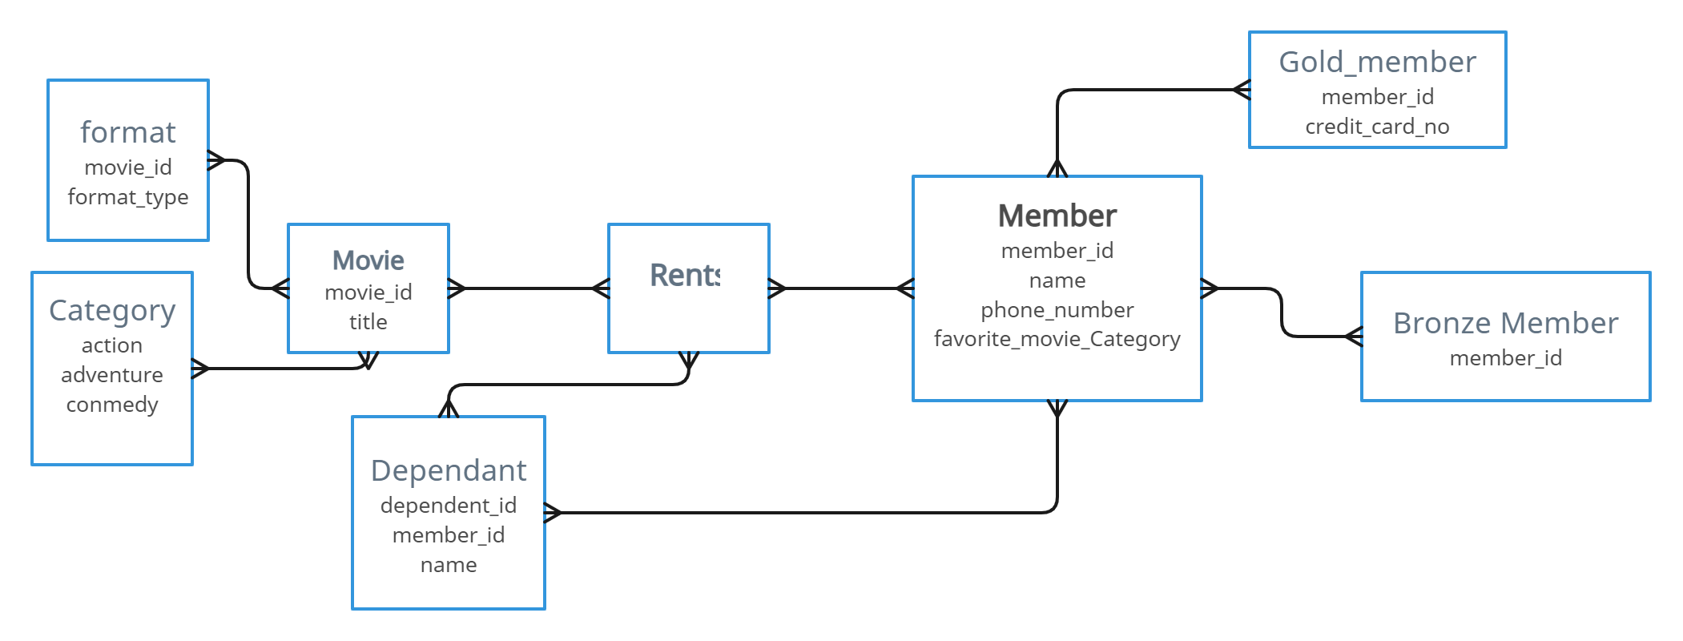

( A little more abstract case )

Create an ER Diagram for a student registration system where the entities are Students, Instructors, Courses and Schedules. Consider all the possible pairings. (Given not in statements form, but in a summarized way)

Assumptions:

A student is taught by one or more Instructor

A student joins only one course

An Instructor may teach any number of students

An Instructor takes atleast one course

A course will have only one schedule

A course may have many students

A course is taught by only one Instructor

A schedule may be used for many courses

